 | Vehicle Reservation System  Technical Design Document  1.0
 | Prepared By / Last Updated By | Reviewed By | Approved By
Name | Subham Pandey | Gopal Upadhyay
Role | Team Member | Scrum Master
Signature
Date

Table of Contents

1.0 Introduction 3
1.1 Purpose of this document 3
1.2 Scope 3
1.3 Intended Audience 3
1.4 Definition & Acronyms 3
2.0 Conventions and Standards Followed 4
3.0 Assumptions, Dependencies and Risks 4
3.1 Assumptions: 4
3.2 Dependencies: 4
4.0 Schematic Diagram 4
5.0 Use Case Realization 5
5.1.1 User Registration 5
a. Functional Requirement 6
b. UI Validations 6
c. UI Controls 7
d. UI Methods Definition 8
e. UI Design 9
6.0 Database Design 10
6.1 Data Model 10
6.2 Tables Structure 10
7.0 Change Log 13

Introduction

Purpose of this document
The purpose of the detail design document is to define the detailed design for all the components of Vehicle Reservation system that are specified in the Business Requirement/Use case document. All the low level components, interfaces and integrations are detailed out in this document.

Scope
This sub-section shall state the scope of this detailed design document
• Create and maintain Admin information.
• Create and maintain Vehicle information

Intended Audience
The intended audience for this document are
- Developers, testers, other associates in the project
- Technical lead, Scrum Master
- Product Owner

Definition & Acronyms
Acronyms | Definitions
VRS | Vehicle Reservation System

Conventions and Standards Followed
The modules under scope needs to adhere to the coding standards and guidelines
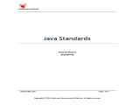
(Click the above icon for java standards and guidelines)

Assumptions, Dependencies and Risks

Assumptions:
- Once the application is built the Vehicle Reservation System will manually load the user list into the system.
- There will be no concurrent users for the application. The Vehicle profile will be maintained by the Admin.
- Any changes to the design mentioned in the BRD would be taken as a Change Request

Dependencies:
- Availability of database design characteristics & access shall be defined by the
- Resource availability throughout each of the sprint

Schematic Diagram
A schematic, or schematic diagram, is a representation of the elements of a system using abstract, graphic symbols rather than realistic pictures. It gives an overview of overall system
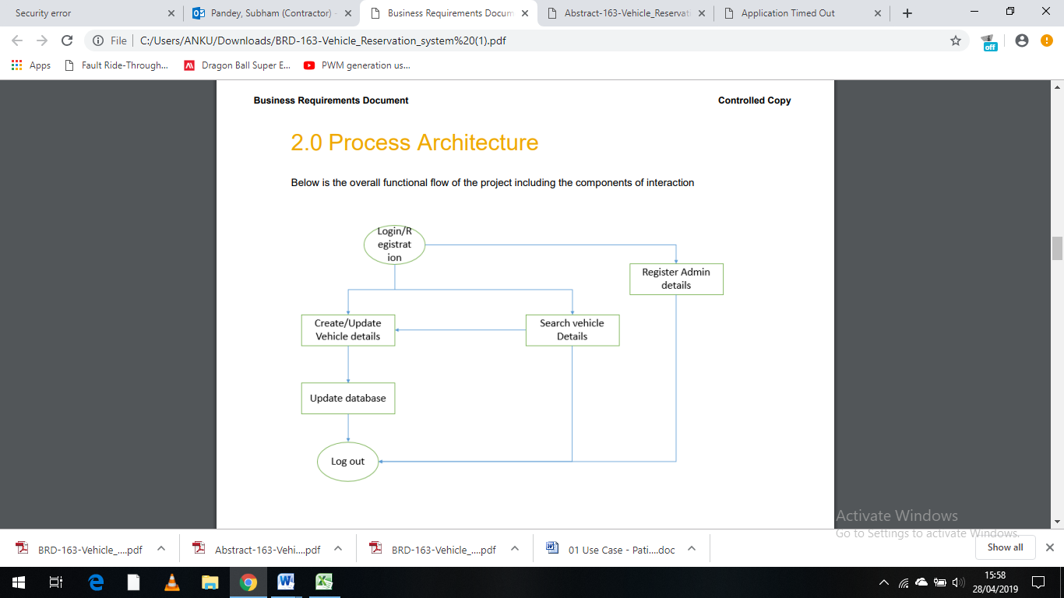

The above pic is only an example and not representational of the Vehicle Reservation System

Use Case Realization

User Registration
5.1.1.1 Login Page

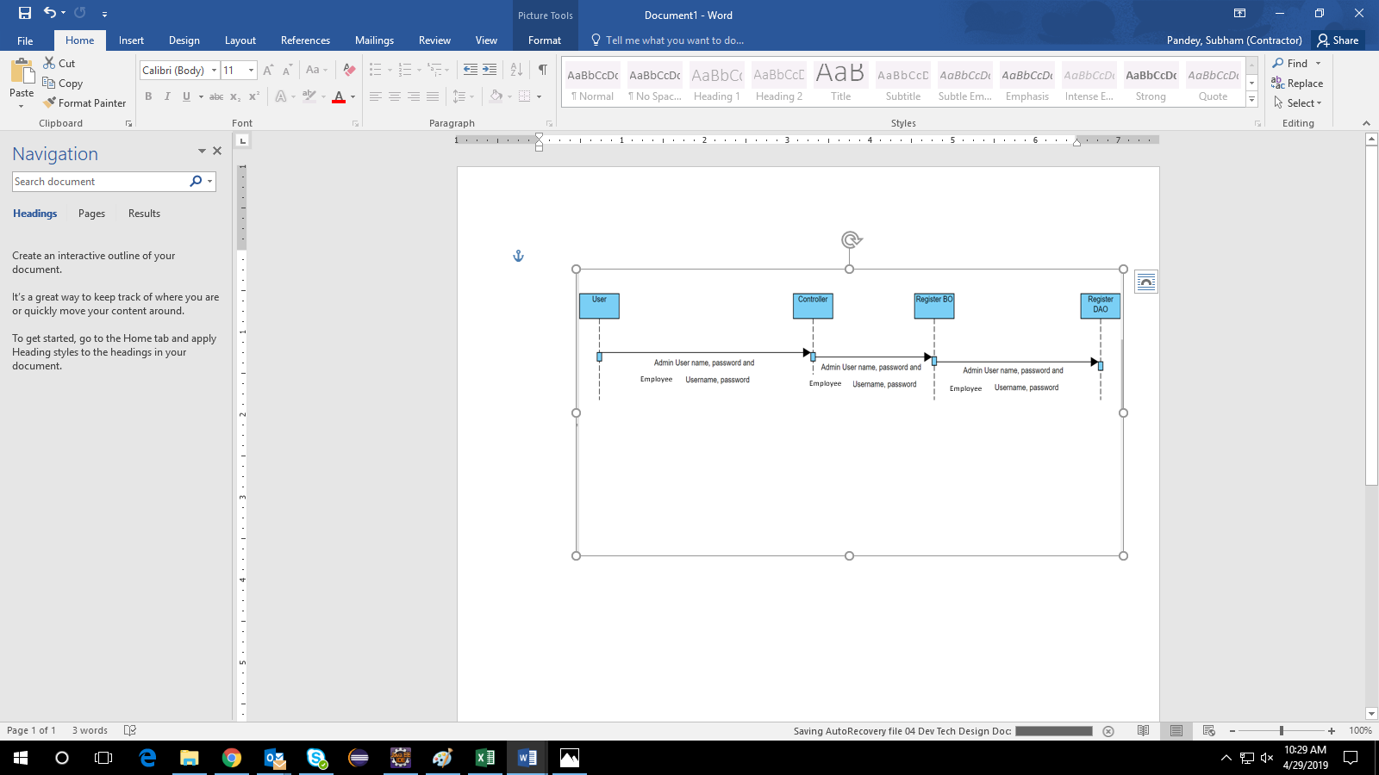
5.1.1.2 User Registration Page
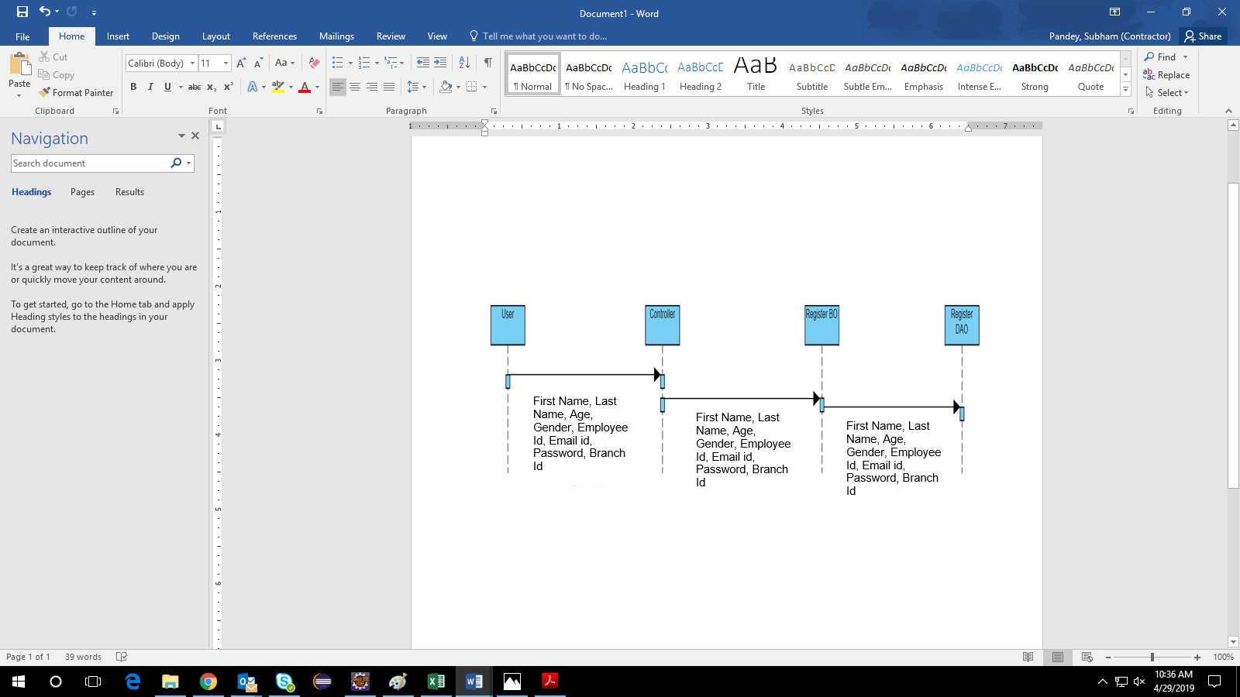

5.1.1.3 Create Vehicle Page
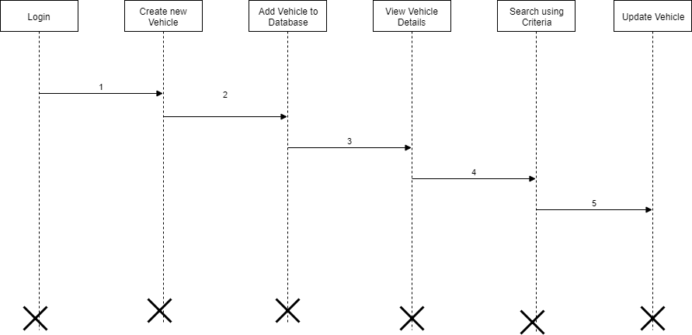

Functional Requirement
. Login Page checks the authentication of the user and based on his role, directs the user to the respective page. User will provided with Add Patient, Details, Regulation and Search regulation pages and the same user will allowed to see Diagnosis Reports and patient vital parameters reports

UI Validations
- User Id and Password fields are mandatory.
- Invalid User Id and / or password should not allow the user to get into the system

UI Controls
# | UI Component | Type | Name | Details
1 | Employee Id | Label | label_For_User_Id
2 | password | Text field | Label_for_password

UI Methods Definition
Method Name | Parameter | Details
Login_Button_Click | object sender, EventArgs e | Allows the Admin/Employee to login
SignUp_Button_Click | object sender, EventArgs e | Allows the Admin/ Employee to register
Register_Button_click | object sender, EventArgs e | Allows the Admin/ Employee to validate the datatype constraints for each field.  Post-successful field level validation, save the information in the database
Create New Vehicle _Button_Click | object sender, EventArgs e | Admin/ Employee should be able to update the mandatory fields of the Vehicle

Submit_Button_Click | object sender, EventArgs e | Allows the vehicle details should be submitted to database.
Update Vehicle_Button_Click | object sender, EventArgs e | It should allow editing or modifying details of the vehicle
View vehicles_Button_click | object sender, EventArgs e | It should display all the vehicles created by the admin.
Employee / Admin_Log off_Button_click | object sender, EventArgs e | Option to log off from the system.

UI Design

Database Design

Data Model

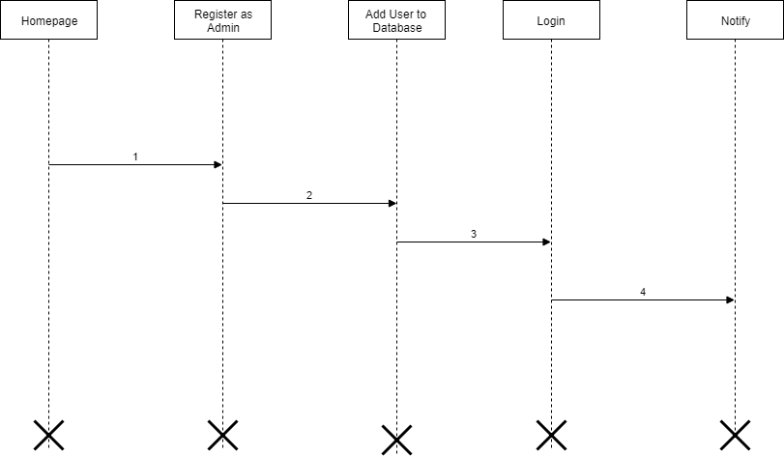
The following is a schematic view of the database design

Tables Structure

User Registration:
Field Name | Field Type | Data Type | Mandatory
Employee Id | Text(10) | Alphanumeric | Yes
First Name | Text(50) | Alphabetic | Yes
Last Name | Text(50) | Alphabetic | Yes
Age | Numeric(2) | Numeric | Yes
Gender | Drop Down | NA
Contact Number | Text(10) | Numeric | Yes
Email ID | Text(50) | Alphanumeric | Yes
Password | Text(15) | Alphanumeric | Yes
Branch Code | Text(5) | Alphanumeric | Yes

User login:
Field Name | Field Type | Data Type | Mandatory
User ID | Text(10) | Alphanumeric | Yes
Password | Text(15) | Alphanumeric | Yes

Vehicle Details:
Field Name | Field Type | Data Type | Mandatory | Possible Values | Field Name
Vehicle No | Text(10) | Alphanumeric | Yes |  | Vehicle No
Branch | Text(5) | Alphabetic | Yes |  | Branch
Vehicle type | Text(15) | Alphabetic | Yes |  | Vehicle type
Insurance Expiry date | Text(10) | MM-DD-CCYY | Yes |  | Insurance Expiry date
Last Serviced Date | Text (10) | MM-DD-CCYY | Yes |  | Last Serviced Date
Service Due date | Text (10) | MM-DD-CCYY | Yes |  | Service Due date

Terms & Conditions:
Field Name | Field Type | Data Type | Mandatory | Possible Values
Contract ID | Auto- generated(8) | Numeric | Yes
Term1 | Text(100) | Alphabetic | Yes
Term2 | Text(100) | Alphabetic | No
Term3 | Text(100) | Alphabetic | No
Term4 | Text(100) | Alphabetic | No
Term5 | Text(100) | Alphabetic | No
Condition1 | Text(100) | Alphabetic | Yes
Condition2 | Text(100) | Alphabetic | No
Condition3 | Text(100) | Alphabetic | No
Condition4 | Text(100) | Alphabetic | No
Condition5 | Text(100) | Alphabetic | No

Amenities:
Field Name | Field Type | Data Type | Mandatory | Possible Values
Contract ID | Auto- generated(8) | Numeric | Yes
Amenities1 | Text(100) | Alphabetic | Yes
Amenities2 | Text(100) | Alphabetic | No
Amenities3 | Text(100) | Alphabetic | No
Amenities4 | Text(100) | Alphabetic | No
Amenities5 | Text(100) | Alphabetic | No
Other Info | Text(100) | Alphabetic | No

Change Log
Please note that this table needs to be maintained even if a Configuration Management tool is used.
Version Number | Changes made
V1.0 | <First version>
V1.1 | <If the change details are not explicitly documented in the table below, reference should be provided here>
V1.1 | Page no | Changed by | Effective date | Changes effected
V1.2 | <If the change details are not explicitly documented in the table below, reference should be provided here>
V1.2 | Page no | Changed by | Effective date | Changes effected

